Comments on Visualization Tool

Camila Lima Zanini (UFZ – ETOX) feedback and comments Ptox Chemical Selection ([http://ptox-chem.russelllab.org](http://ptox-chem.russelllab.org/))

Tested using MicrosoftEdge and Firefox on the desktop and using Brave on the smartphone

# “Network” tab:

* I would remove the zoom using the scroll from the mouse. The normal zoom pressing ctrl and using the scroll would be better
* I would make the only appear once you select the class, since it is useless before that and can create a bit of confusion
* I don’t know what those two  icons do.. Maybe a mouse over to explain
* It took me sometime to realize that there was a list bellow the network itself. I would put some indication.

# “Use” page:

- After selecting one class, the names overlap (not dependent of zoom)

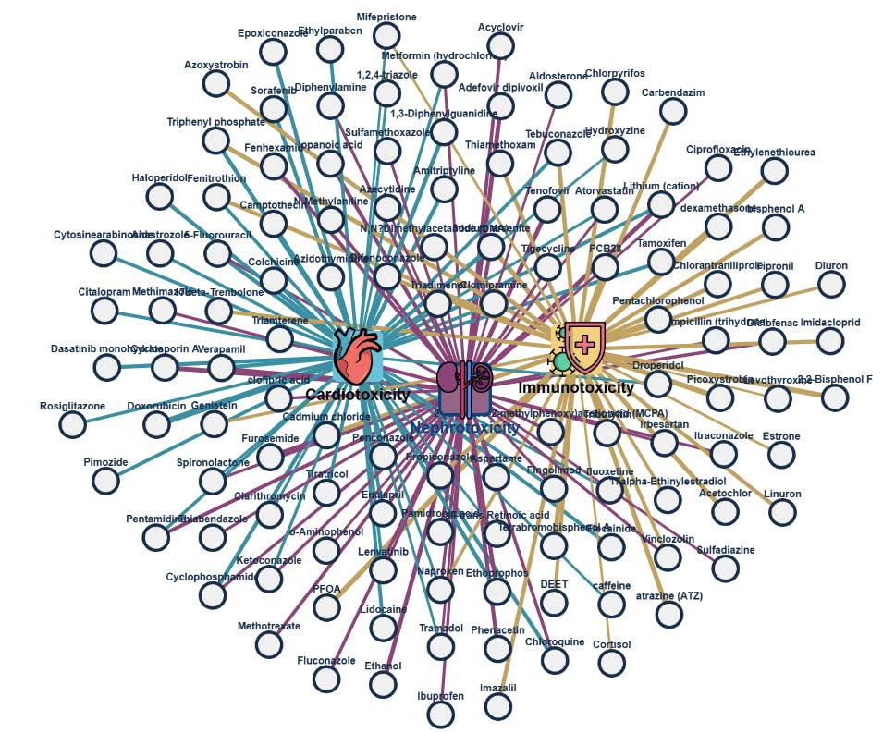

# “Toxicity” page:

- When selecting multiples effects, it is hard to check intersections.

Example – Lithium is cardiotoxicant and nephrotoxicant but you have to find this information visually

Possible solution:

Having the option to move all nodes from the same category at once. Something like: left click moves only

the effect node, right click move all the nodes from this category and nodes that belong to more then one effect stay still. Or having an option on selecting multiples nodes at the same time using a select box. I checked, and pressing control wail clicking on the nodes does allow to move them at the same time, but this information could be written somewhere. Or having a filter option that allows to check this type of overlaps

* I would add a mouse over to the “Score” column on the table bellow the network explaining what it means
* The download option is only for the network itself, it does not come with the table. Maybe add an option for downloading the table as well
* The table shows only the last clicked effect node, but it could have an option of showing both.

Maybe having focus on the intersections.

# “List” tab:

* It would make great use of filters. I imagine someone playing with the network, then finding some interesting compounds and wanting to check their information on the list and downloading all in the same table.

o Maybe bellow the overview table add another one named “selected table” or something like this with all compounds that you select on the overview one

Cramer von Clausbruch, Christina Alexandra (IBCS) [christina.cramer-von-clausbruch@kit.edu](mailto:christina.cramer-von-clausbruch@kit.edu)

I’ve been briefly giving the tool a test run and here are my comments:

I like the icons. The list in itself is useful to cross-reference. I like the idea behind I can select a compound and then see uses and targets and the tox data.

My main point of possible improvement is readability- for example AOP texts and such are hard to read as the text overlays wildly with everything else.

Another point for ease of use – if for example now I’ve clicked the AOP for PTX031 and it isn’t readable due the layering I can only drag every element by itself -> an option to drag everything associate to the main icon of AOP out of the way to read it would be amazing.

The jerking and complete rearrangement when one clicks on another of the main icons like BaselineTox or targets could be smoother and the complete rearrangement requires reorientation every time you click on anything new – maybe there is a better way to handle this?

Matthew Symington <matthew.symington@michabo.co.uk>

I have a minor suggestion for improvement:

It would be useful to add an additional filter, to allow the selection of compounds both on toxicity AND use (pharma/industrial etc.) if possible,

e.g. filtering pharmaceutical cardiotoxins, or industrial chemicals that are hepatotoxic...

this would fit perfectly as a video tutorial once you have feedback from the consortium

please let us know what you think about it and we can discuss how to produce the video.

all the best

francois

Chemical library tool looks really impressive! Here are few things which in our opinion can be improved:

1. To provide additional practical handling information—such as light sensitivity, storage conditions, "do not" instructions, and hazard classification—would be very useful for scientists to quickly and easily access necessary details before experiment.

Handling

information?

1. Some tiles are overlapping. Can they be more spaced out from the beginning?

now sorted?

1. A diagram of a network of molecules

   Description automatically generated with medium confidenceCan clusters remain in the same position each time? Once the user sorts them as preferred, clicking on an extra tile reorganizes their position again.

now

Tiles stay in same position

1. Selecting toxicity for specific organs: Can the arrangement of tiles be more organized, like a Venn diagram? For example, after selecting three organs, chemicals that are toxic to multiple organs should be positioned in the overlapping areas, as shown in the picture below.

now Venn diagram-like sorting?